Computer Language Coding Concepts

Assignment in a Diagram
The principle of assignment is explained in the article Assignment. This article demonstrates the expression of it in a diagram.

There are several types of assignment, for instance value assignment and object assignment. All assignments are displayed as a call to a special system command: an assignment command. An assignment command has two parameters: the source and the target.

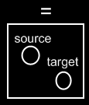

The source is a Reference In parameter, the target is a Reference Out parameter. The parameter types can be shown as follows in a diagram of an assignment command definition:

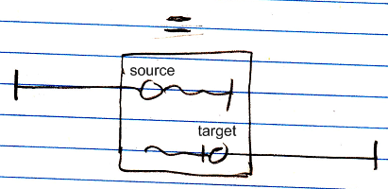

The notation of the different parameter types is discussed in the article In, Out, Thru & Downput Parameters.
A call to the assignment command would look like this:

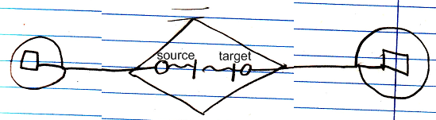

But assignment is so fundamental and common, that is is given a more basic notation, like the following:

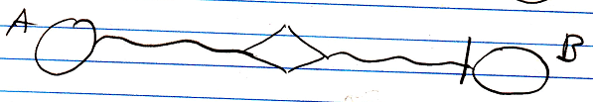

This is a value assignment. The value of object A is assigned to object B. The line type indicates what type of assignment it is. The access mark indicates the direction of the assignment. The command name is not displayed (=), the parameters are not displayed and the object commands are not displayed.
The below is an object assignment:

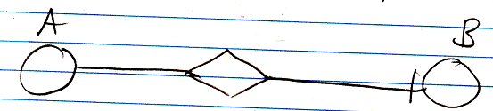

The solid line is what makes it an object assignment. The target object of symbol A is assigned to symbol B.

Assignment with Get & Set
An assignment is actually a combination of a Get and a Set call. Instead of using a call to an assignment command, you could also use a call to the Get and Set system commands:

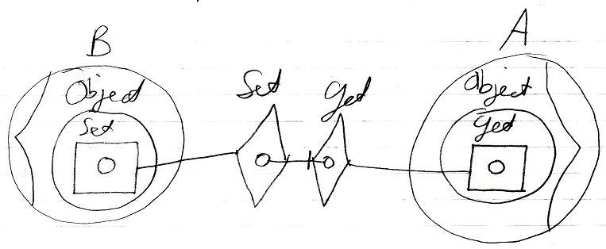

You can also call the Set command and in its call refer to Get’s object out parameter, causing an implicit call to the Get command.

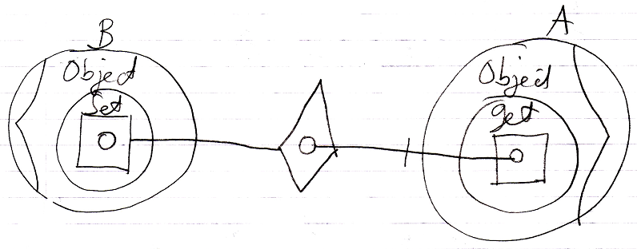

Instead of showing the objects’ system interfaces you can also show a call to a system procedure in a more basic form:

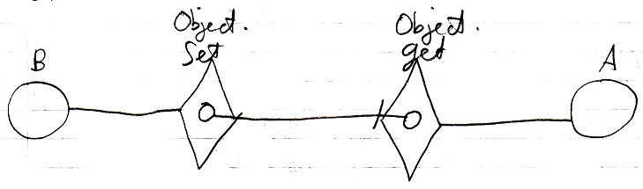

As you can see in the diagram above, system commands, just like assignment commands, also have a simpler notation than other commands.
You can not just show a Set command call using the simpler notation of system commands, because you have to display the Get command in order to reference its object out parameter.

Because it is more intuitive to use a single assignment call, instead of a separate Get and a Set call, and assignment is so fundamental, there are the assignment commands:

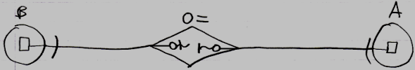

and their simple notation:

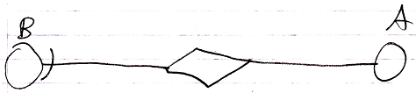

The implementation of the assignment command can be the same as what we did with the Get and Set commands. Here is a diagram of each of those forms, now used as the implementation of the assignment command:

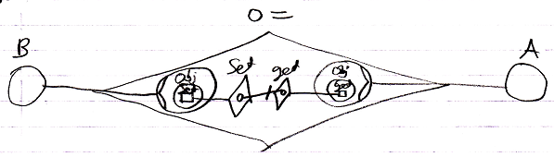

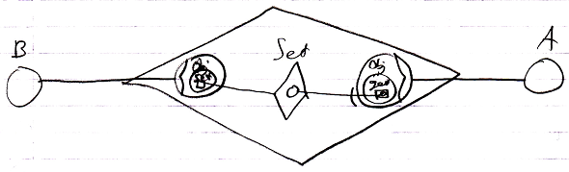

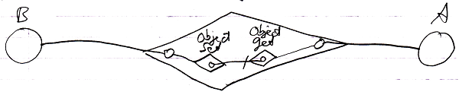

Knowing how to use Get and Set commands, instead of a single assignment call, gives you a low-level understanding of assignment. This low-level understanding is important in order to create alternative forms of assignment, as explained in the article Alternative Assignments.

See also: Assignment, In, Out, Thru & Downput Parameters in a Diagram, Alternative Assignments

Author & Copyright: Jan-Joost van Zon Date: May 25, 2008 – July 28, 2008 Location: Oosterhout, The Netherlands Status: Finished

